Github - https://github.com/gdd-shobhit/UCAssignments/tree/main/Advanced%20Programming%20Languages/Assignment3
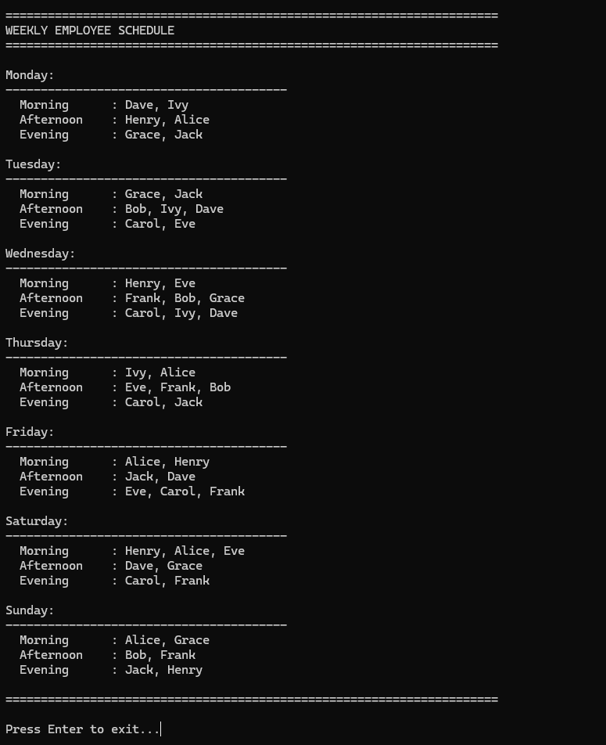
C++ result

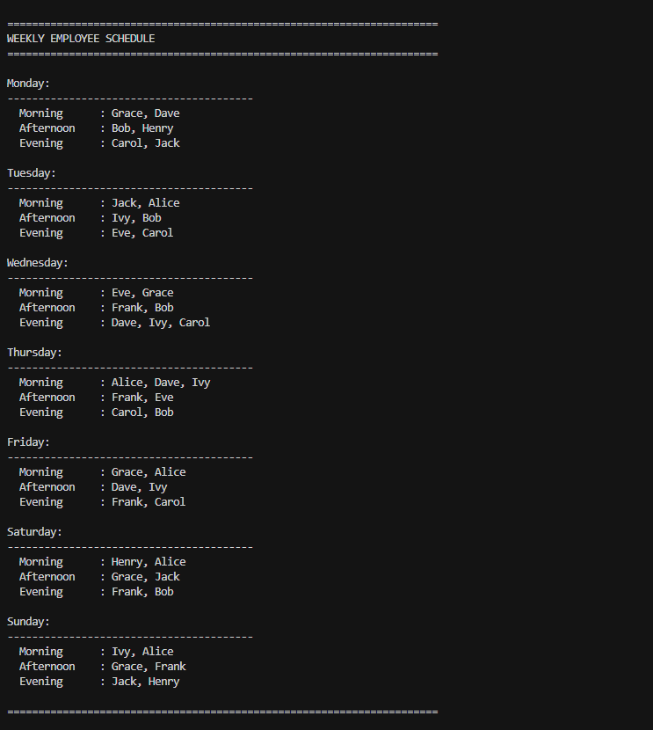
Python result

